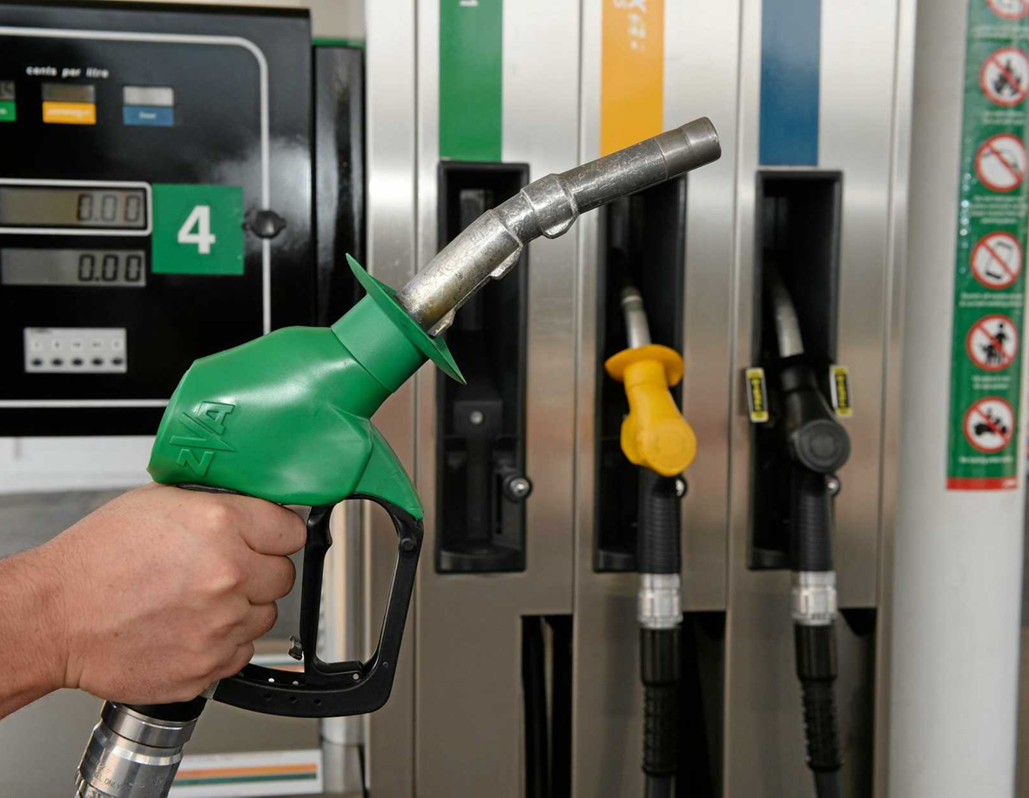

Minimum Standard Guidelines for the Management of Coronavirus (COVID-19) – Petrol & Service Stations
Version 1.1
Date: 3 April 2020 (Updated 15 April 2020)

Introduction
Due to the COVID-19 pandemic, all petrol and service stations are required to take extra precautions and implement strict processes and procedures in order to reduce the spread of the virus. This is achieved by ensuring adequate physical distancing and hygiene measures are in place.
Petrol and service stations are an essential service to the community and will remain open. Community visitation will remain high and this provides an increased risk of spreading the virus.
Physical distancing and prevention of spread of COVID-19 via contaminated surfaces is important in your business. These guidelines have been developed to help support and provide advice to petrol and service stations within the Surf Coast Shire to reduce the spread of COVID-19 in our community.

Petrol bowsers
- Provide disinfectant wipes at petrol bowsers for customers to wipe handles prior to use. If disinfectant wipes cannot be sourced, a chlorine solution of 1000ppm diluted fresh each day can be used on paper towels. (Refer to Table 1 and Table 2); and/or
- Provide paper towel so customers can use to handle the petrol bowser
Photo 1 – Petrol bowser with clear signage
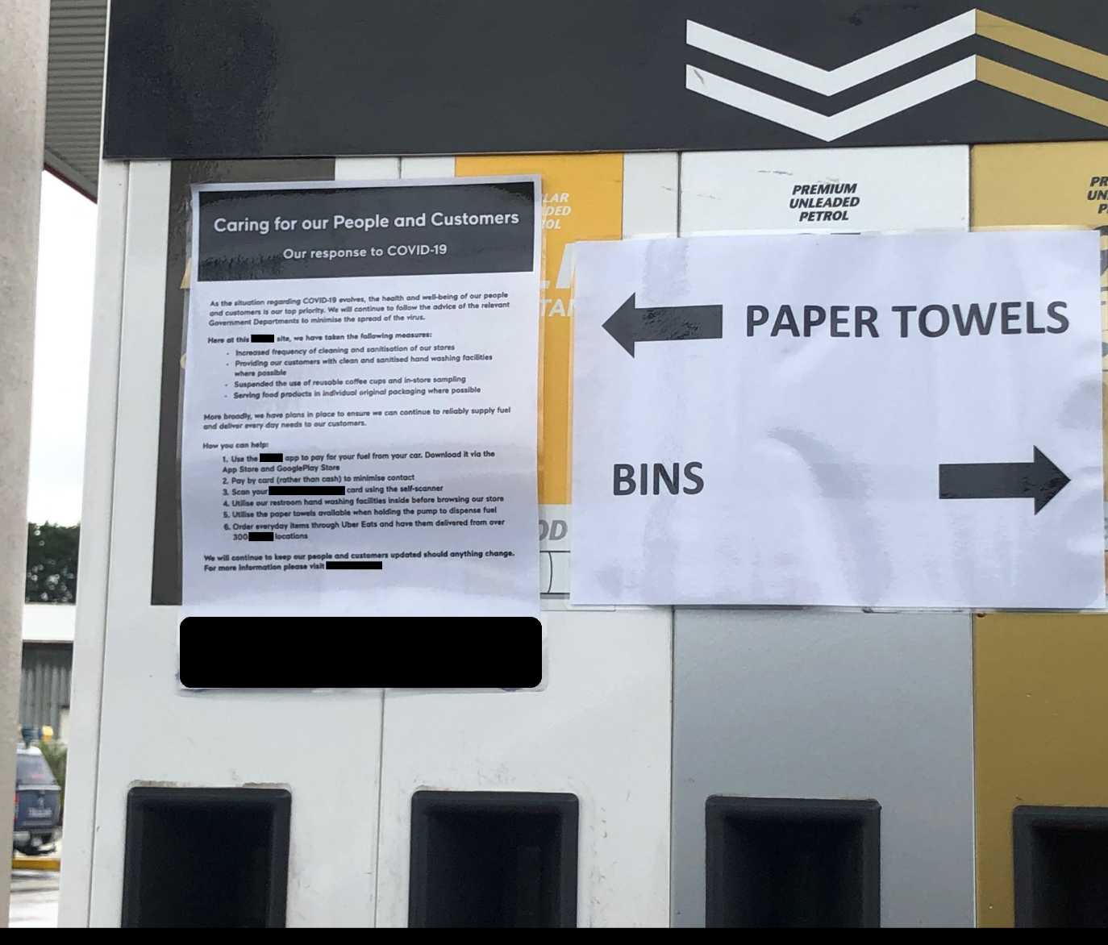

Entrance to store
- Provide a temporary hand wash station or hand sanitiser at the entrance of the store for customer use. Customers should be directed to use this prior to entering the store.
- Provide signage (that stands out) with instructions on these steps.
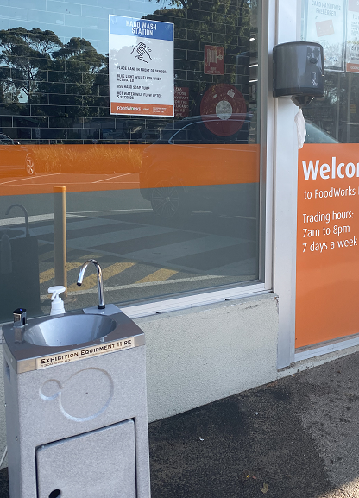
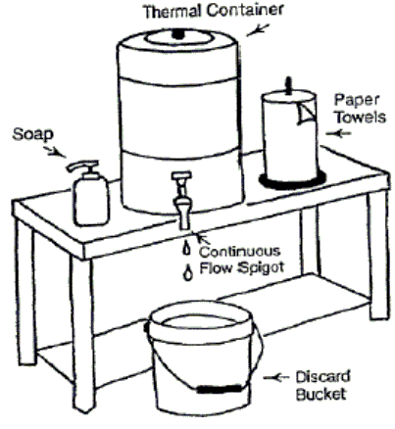

Photo 2— How to set up a temporary hand Photo 3 – Picture of a temporary hand wash station wash station

Density Signage
Measure the floor space of the store to work out how many square metres of accessible public floor area. Divide this number by 4 to work out how many people are permitted within the store at once. The number permitted is to be displayed on a sign at the entrance.

One way traffic flow
Where possible promote a one way flow throughout the store. If you have multiple entrances, dedicate one as an entrance and the other as an exit.
Consider arrow markings on the floor to indicate the direction customers should walk through each aisle and throughout the store. The purpose of this is to avoid customers having to walk around each other or towards one another. This will hopefully minimise congestion.

Social distancing markings
Wherever people queue within the store i.e. entrance and checkouts, provide space markings on the floor at a minimum of 1.5m apart to indicate where people are to stand. Markings need to be bright coloured or of a pattern that stands out. Signage should be used to reiterate the 1.5m distance message and bring this requirement to the customer’s attention.
Photo 4 – Picture of social distancing markers
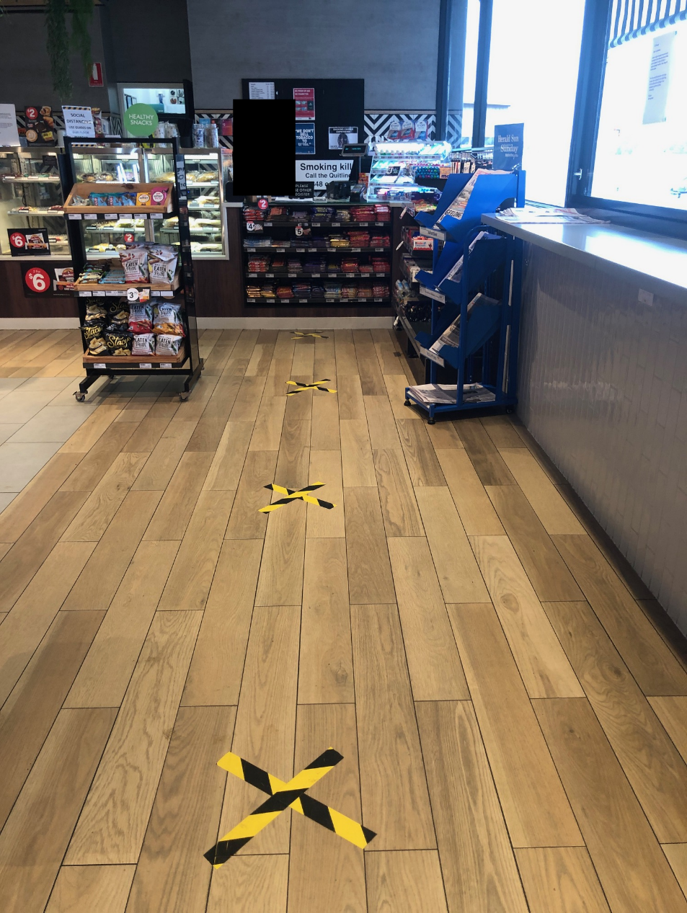

Cleaning
Throughout the COVID-19 pandemic additional cleaning needs to be carried out throughout the store according the Victorian Chief Health Officers directions. The focus needs to be on frequently touched surfaces. You may need additional cleaning staff to carry out these duties or assign certain staff to cleaning duties.
All reasonable steps must be taken to ensure:
- Frequently touched surfaces are cleaned at least twice a day. Frequently touched surfaces may include:
  - Door handles e.g. fridges, display cases
  - Self-serve coffee machines
  - Self-service displays and utensils e.g. Tongs, scoops
  - Service counters/check-out areas
  - Hand rails
  - EFTPOS keypads
  - Bathrooms
- Surfaces are cleaned when visibly soiled; and
- Surfaces are cleaned immediately after a spill on the surface.

Cleaning Products
Use a disinfectant for which the manufacturer claims antiviral activity (meaning it can kill viruses). Chlorine-based (bleach) disinfectants are one product that is commonly used. Other options include common household disinfectants or alcohol solutions with at least 70% alcohol.
Follow the manufacturer’s instructions for appropriate dilution and use.
Chlorine dilutions calculator
Household bleach comes in a variety of strengths. The concentration of active ingredient — hypochlorous acid — can be found on the product label.
Contact time is usually 10–30 seconds but check the manufacturer’s instructions
Throw diluted bleach away after 24 hours.
Table 1. Dilutions using household liquid bleach (with 4% available chlorine as written on the label).
Household bleach 4% available chlorine | Add the following amounts of bleach to the water to give the required concentration
Volume of water to which chlorine is added | 1000ppm
1 litre | 26.3ml
5 litres | 125ml
10 litres | 250ml
Table 2. Dilutions using household liquid bleach (with 12.5% available chlorine as written on the label).
Household bleach 12.5% available chlorine | Add the following amounts of bleach to the water to give the required concentration
Volume of water to which chlorine is added | 1000ppm
1 litre | 8.4ml
5 litres | 42ml
10 litres | 84ml

For other concentrations of chlorine-based sanitisers not listed in the table above, a dilutions calculator can be found on the department’s website <www2.health.vic.gov.au/public-health/infectious-diseases/infection-control-guidelines/chlorine-dilutions-calculator> .
Please also refer to the Victorian Department of Health and Human Services, Cleaning and disinfecting to reduce COVID-19 transmission.

Staff health and hygiene
Ensure hand washing facilities and hand sanitisers are made readily available to staff.
Educate staff to maintain good social distancing 1.5m from customers and one another.
Educate staff so that they are not touching their nose, mouth and face. If they do then they must wash hands with soap and water, and dry with paper towel.
Ensure any staff member that has been overseas in the last 14 days OR who have any symptoms of respiratory infection i.e. fever, sore throat, runny nose, cough, shortness of breath, or has been a close contact to someone confirmed a COVID-19 case DOES NOT WORK.

Payments
Promote cashless payments. If cash is necessary and there are multiple counters, consider dedicating one counter for cash sales only. If money has to be accepted, implement a procedure where the two people do not physically touch such as placing the money on the counter. Ensure that hands are washed with soap and water, or a hand sanitiser is used.

Do staff have to wear masks and/or gloves?
Masks – the current advice is that masks are not necessary. For people that can practice good physical distancing and hygiene in their workplace, masks are not required.
Gloves - Gloves should only be used if part of the businesses normal procedures for food safety i.e. when handling ready to eat foods. Similarly to masks, the focus should instead be on good physical distancing and hygiene. Gloves can cause more of an issue as they are often not changed regularly enough and can become a source of contamination.

Truck stops
If your food and drink operation is situated on a major transport route and has a dedicated section providing food and drink to help alleviate fatigue for drivers of long-haul heavy vehicles, you may continue to operate that dedicated section, ensuring the four square metre rule is observed. Drivers must not remain in that dedicated section for more than one hour at a time and there must be at least 1.5 metres between people at all times.

Communication with customers
It is important that you maintain contact with your customers and the community via means such as social media and website updates. This is an opportunity for you to advise the community of any policy and procedure changes, in particular ones that will impact your customers.
We have seen social media being used to update customers on stock supply issues, changes in procedures such as moving to cashless payments only and asking the community to do the right thing by maintaining physical distancing and only sending 1 family member to the store at a time.
The use of these platforms can be beneficial in demonstrating to the community that you are taking the COVID-19 issues seriously. Providing regular updates to your customers, particularly as things change, will help them stay informed and know what to do when they visit your store.

Physical Barriers
Provide a physical barrier such as Perspex between customers and counter staff.
Where physical barriers are not practical to install, you may want to use barrier tape or furniture can be placed between customers and counter staff to ensure 1.5m can be maintained.
Photo 5—Perspex barrier at cash register
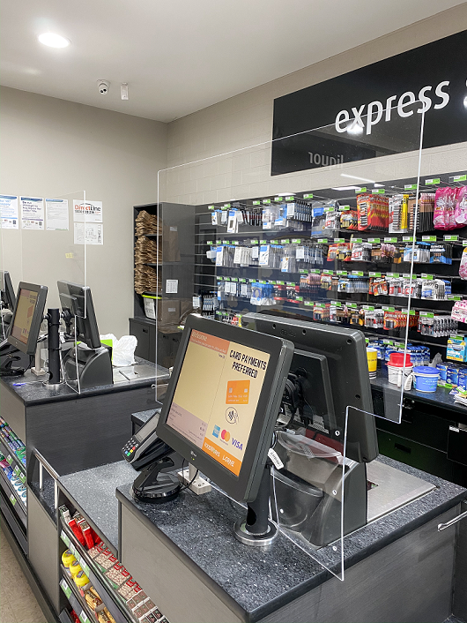

Additional things to consider
- Stopping/reducing visitations other than customers that are not essential such as sales representatives.
- Restricting the number petrol pumps open to reduce customer numbers within the store.
- Suspend in-store sampling.
- Serving food products in individual original packaging where possible.
- Provide gloves for customers at self-serve coffee machines.
- Promote food delivery services to customers.

Where can I find more information?
- Surf Coast Shire Coronavirus (COVID-19) Update at www.surfcoast.vic.gov.au/covid19
- Stay informed directly with DHHS via www.dhhs.vic.gov.au/coronavirus or the 24 hour hotline 1800 675 398.
- Cleaning and disinfecting to reduce COVID-19 transmission, available at www.dhhs.vic.gov.au
- Vic Health www.vichealth.vic.gov.au
- Food Standards Australia New Zealand - FSANZ at www.foodstandards.gov.au
- World Health Organisation at www.who.int/health-topics/coronavirus
- Premier of Victoria at www.premier.vic.gov.au
- Business Victoria at www.business.vic.gov.au

References
Department of Health and Human Services - https://www.dhhs.vic.gov.au/coronavirus

You can contact the (insert name of Council and contact details)

Environmental Health Professionals Australia wishes to thank and commend the Surf Coast Shire Council for developing and allowing us to provide this document to EHPA members.

