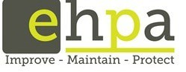
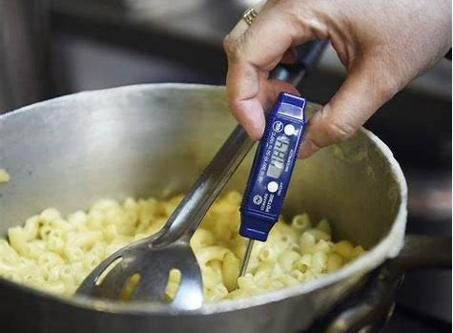

Management of Coronavirus (COVID-19)
Public Health Field Inspections and Investigations
Version 1.0
Date: 3 April 2020

Public Health Field Inspections and Investigations

As most of our work will be out in field, we will need to take strict precautions to ensure we protect ourselves and that of the person we engage with during the conduction of inspections investigation etc.
We have conducted a risk assessment of our inspection process in the field and this process has been set up for you to follow to minimise risk of coronavirus contamination.

Questions: Please confirm the following with proprietor/contact via phone prior to attendance

Are you happy for me to attend premises? Y N
Can adequate social distancing be maintained at premises? Y N
Have you or any staff member had (confirmed or suspected) CoronaVirus (COVID-19) in the last 4 weeks Y N Have you or any staff member currently ill or have been ill in the past 14 days? Y N
Have you or any staff member travelled overseas or interstate in the past 28 days? Y N
Have you or any of your staff members immediate family members or people they live with are currently ill or have been ill in the past 14 days? Y N
If Y to any above questions, what steps have been taken since?

Note: - If any answers are Y to above please conduct phone assessment only or discuss with SEHO/Coordinator.
Where a high risk environment has been identified, or the premises is a rooming houses, PPE must be worn

When phoning, also ask:
How many people are expected to be present at assessment/inspection?
Explained that you will be practicing social distancing of 1.5m and would appreciate that they maintain their distance. Approximate age of staff that will be present (higher risk group?)
Current trading hours? *complete table above

Name of person contacted:

Note: - if attending, minimise the amount of time you spend onsite and avoid face to face contact and follow WHO guidelines. Wash hands when first entering and when leaving

Make sure up have the following items before leaving:
  - Surface wipes
  - Hand sanitiser
  - Inspection book; checklist for inspection during coronavirus
  - Phone
  - Info sheets and printouts for food premises from DHHS.
  - Seizure books, thermometer & wipes
  - Body Camera
  - P2 Masks and Single use gloves (if assessed you are entering a high risk environment)
  - Rubbish bags (to dispose of PPE)
  - Bowl, water, liquid soap and paper towel (portable hand wash station)

Thoroughly wipe down of the car before you head off on the road. Even if you take your own car, get into the habit of keeping your touch surfaces clean.
  - Steering wheel
  - Indicator
  - Gear shift
  - Door handle
  - Wipers
  - Headlight switch
  - Seat belt

When you arrive at a premises do a quick observation:
  - How many people are in the premises? As rule if you see 4 or more and the spacing is tight - wait for customers to leave before entering
  - Where possible, you must achieve the rule* of 1 person for every 4 square metres to ensure safe physical distance? Maintain distance 1.5 m

If you don’t think you can meet step 3:
  - Wait near the premises until it is safe to do so
  - Ring the proprietor and inform them of who you are, why you’re there and if they can be present for your inspection at same other time. *Be sure to put your private mobile number on private OR make a call from your device*.
  - Leave your details for the proprietor and ask when a suitable time to come back is to ensure you can meet the 4spm rule and conduct an inspection, or
Wear PPE and continue to conduct the inspection
  - Worst case don’t do the inspection.

If you can meet the step 3 start your inspection:

Limit your inspection to 1 hour. You are doing a Risk Assessment/risk inspection for the purpose of addressing the risk to public health. “Ideally” if possible, go outside to discuss issues with proprietor eg. back yard, open space etc.

  - Do not place any your items (device, keys books pens) on the premises’ benches/counters. Try and take in the least amount of equipment with you to reduce the need to put things down.
  - Feel confident to ask your proprietor if they have been overseas in the last 2-3 weeks and if they are feeling well.
  - Explain that you are actively applying the social distancing requirements and they should too.
  - Avoid touching where ever possible any surfaces and items in the premises. (if possible while still maintaining 1.5m rule).
  - Wash your hands upon entry and exit of the premises.
  - Wash your hands where you have accidently shaken hands or feel there is a need
  - Conduct your inspection.
- Inform the proprietor that once you have completed your report, you will send email - confirm the email address.
  - Enter your inspection on your database, generate and email report.
  - Always complete your report or off location where it is safe to do so. (inspections can be completed when you get home, use the last couple of hours to go home)

On completion of inspection, when you return to car, re-apply hand sanitiser.

Environmental Health Professionals Australia wishes to thank and commend the City of Greater Dandenong, Mornington Peninsula Shire and Banyule City Council for developing and allowing us to provide this document to EHPA members.

